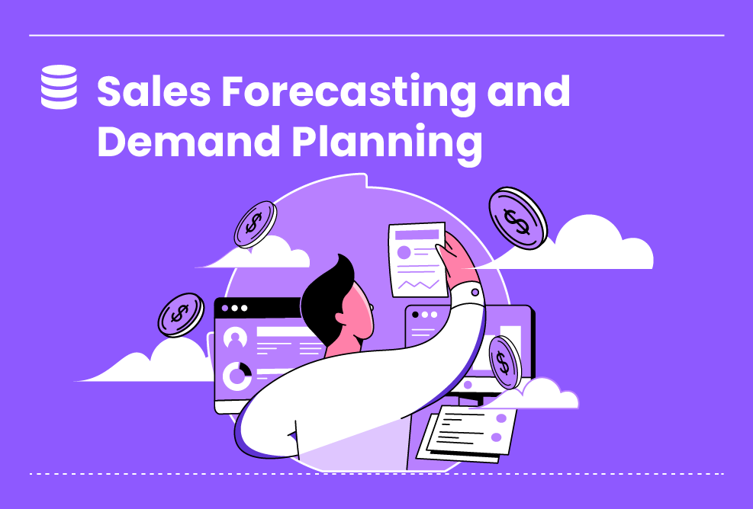

All Levels

**Sales Forecasting and Demand Planning**

In this LP, you will use time-series forecasting to forecast store sales on data from Corporación Favorita, a large Ecuadorian-based grocery retailer. Specifically, you will build a model that more accurately predicts the unit sales for thousands of items sold at different Favorita stores. You will practice your machine learning skills with ...

Duration : 10 Hours

All Levels

5 Steps

**Project Objective**

The objective of the Store Sales - Time Series Forecasting competition on Kaggle is to use Power BI to build a forecasting model that predicts grocery sales. The competition provides a dataset of dates, store, and item information, promotions, and unit sales for thousands of items sold at different Favorita stores. Participants are challenged to build a forecasting model that more accurately predicts the unit sales for these items using Power BI. The competition is ongoing, and the leaderboard is updated regularly. The top teams in the leaderboard are using various forecasting techniques, such as moving averages, exponential smoothing, and ARIMA. Here are some of the benefits of using Power BI for time series forecasting: Ease of use: Power BI is a user-friendly tool that makes it easy to build forecasting models. Visualization: Power BI provides powerful visualization tools to help you understand your data and make better forecasting decisions. Collaboration: Power BI allows you to collaborate with others on your forecasting models.

**Inspiring Project Examples**

https://github.com/topics/time-series-forecasting?l=r&o=asc&s=stars

https://www.mdpi.com/2306-5729/4/1/15

**Step By Step**

On this project, you will pass by these steps. All steps must be done to successfully complete this project.

**Identifying Key Performance Indicators (KPIs)**

Defining Relevant KPIs, Like Forecast Accuracy And Order Fill Rate, Is Vital To Measure Performance. KPIs Should Be SMART, Meaning They're Clear, Measurable, Achievable, Relevant, And Time-Bound. This Way Can Provide Valuable Insights To Improve Sales Forecasting And Demand Planning Processes, Leading To Increased Efficiency, Profitability, And Customer Satisfaction.

**Collecting Relevant Sales Data**

This Phase Involves Collecting Historical Sales Data, Market Trends, Promotional Activities, And Other Relevant Factors That Influence Demand To Inform Forecasting Models. The Data Collection Process Requires Gathering Data From A Variety Of Sources, Like Market Trends Can Be Obtained From Industry Publications Or Government Agencies. Promotional Activities Can Be Obtained From Marketing Departments Or Retailers.

**Analyzing Sales Data**

In This Phase, We Will Apply Statistical Forecasting Techniques, Machine Learning Algorithms, And Market Analysis To Predict Future Sales And Identify Demand Patterns, And Factors Impacting Sales Performance, The Prediction Will Be Evaluated Using A Variety Of Metrics, Such As Accuracy, Precision, And Recall.

**Visualizing Sales Data**

In This Phase, We Will Create Visualizations To Present Sales Forecasts, And Demand Patterns, And Identify Any Gaps Between Predicted And Actual Sales. We Will Use Dashboards To Monitor Sales Performance And Inventory Levels.

**Presentation**

Time To Present Your Work And Showcase Your Approach.

**Instructor Guideline**

1- Import your data into Power BI. 2- Clean and prepare your data. 3- Choose a forecasting technique. 4- Build your forecasting model. 5- Evaluate your forecasting model. 6- Share your forecasting model.

**Guidelines Ressources**

https://github.com/topics/time-series-forecasting?l=r&o=asc&s=stars

https://www.mdpi.com/2306-5729/4/1/15